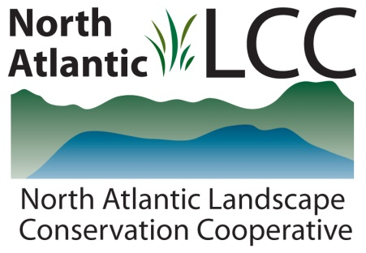

Connecticut River Watershed Landscape Conservation Design Pilot

Project Name | Forecasting Changes in Stream Flow, Temperature and Salmonid Populations in the Eastern United States as a Result of Climate Change
Product Type | GIS data layers showing current and future stream flows, temperatures and brook trout occupancy. Web application to host results.
Product Description | Headwaters constitute 80% of the stream and river kilometers in New England and provide critical habitats for a variety of plants, mammals, birds, reptiles and invertebrates. Substantial variability exists, though, in how stream flows, temperatures and aquatic life respond to current climatic conditions and how they will respond to future climate. The aim of this project was to characterize current variation, to provide forecasts under future climates and to develop a web application to facilitate access and utility of project results.
Geographic Extent and data scale | North Atlantic LCC region. Predictions for each catchment in the region.
Developer | USGS Conte Anadromous Fish Research Center
Contact | Ben Letcher, Ana Rosner
Completion Date | Fall 2014

